Ranoa, Jason

CSC 121 001 Computer Science I

Midterm Part II Submission

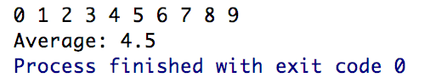

Screenshot:

Output: *sorted.txt*  
 Contains (copied directly): 0 1 2 3 4 5 6 7 8 9

Source Files:

1. *main.cpp*
2. *ArrayUtility.h*
3. *ArrayUtility.cpp*
4. Object Folder > *unsorted.txt*

Source Code:

1. **main.cpp  
   **
2. **ArrayUtility.h**
3. **ArrayUtility.cpp**

*ArrayUtility.cpp is continued on next page.*

***ArrayUtility.cpp – continued.***

